经税务部门沟通后需要将历史复核数据删除，重新推送复核数据分发给各个地市进行数据复核，按照张敏给的SQL 清除表数据后 涉税平台仍然显示复核历史数据。情况截图如下

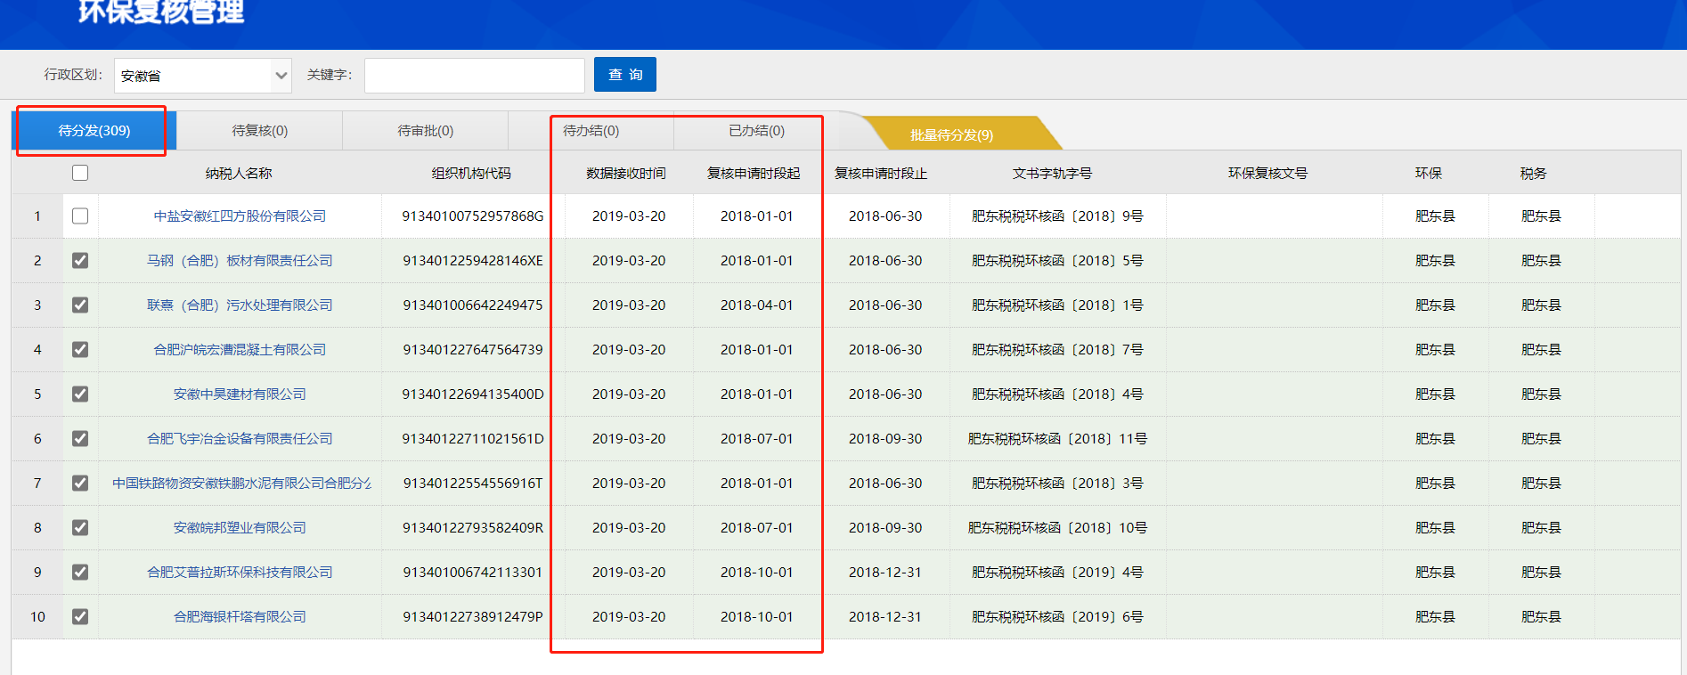

操作SQL如下

DELETE FROM calc.base_info

DELETE FROM env.check_process

DELETE FROM calc.water_output

DELETE FROM calc.water_pollutant

DELETE FROM calc.gas_output

DELETE FROM calc.gas_pollutant

DELETE FROM calc.noise_measuring_point

DELETE FROM calc.noise_source

DELETE FROM calc.solid_pollutant

DELETE FROM calc.solid_stack

DELETE FROM calc.month

DELETE FROM calc.audit

DELETE FROM dbo.HBJH_FHYJ

DELETE FROM dbo.HBJH_FHYJ_ZB_SHARE

truncate table [dbo].[check_circulation]