问题

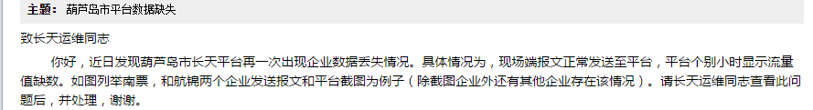

平台地址：<http://10.134.148.13:8080/jointframe/app/AppMain!index.page>

Xuqw 111111

1.南票焊电有限公司 210000009193

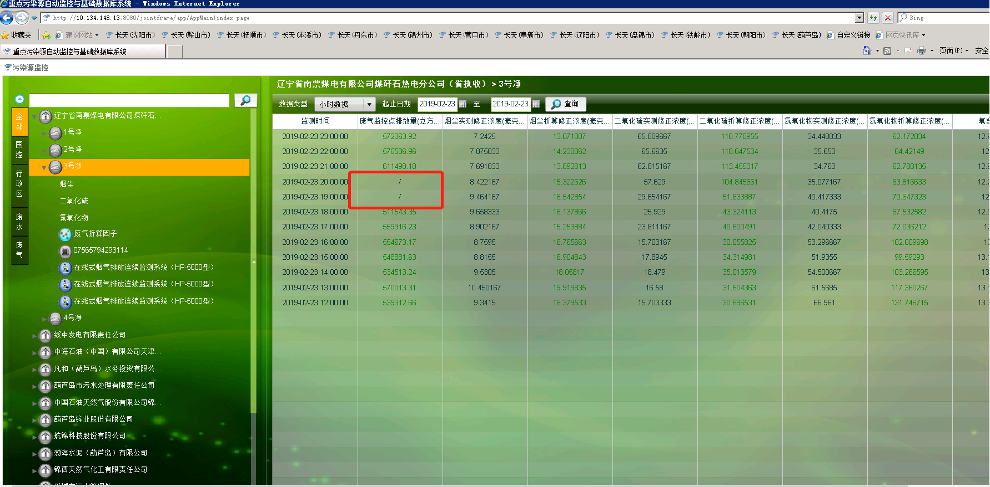

2.航锦科技股份有限公司 211400000011

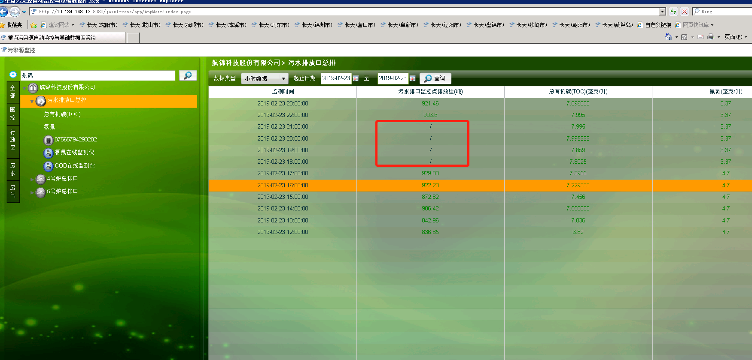

原始报文

##0314QN=20190223200000000;ST=32;CN=2061;PW=123456;MN=07565794293202;Flag=0;CP=&&DataTime=20190223200000;060-Avg=1.562,060-Min=1.562,060-Max=1.562,060-Cou=1.232694;001-Avg=7.055667,001-Min=7.036,001-Max=7.164,001-Cou=5.568166;015-Avg=7.995333,015-Min=7.995,015-Max=8.01,015-Cou=6.309729;B01-Avg=789.1765,B01-Cou=789.18&&EA41

##0312QN=20190223180000000;ST=32;CN=2061;PW=123456;MN=07565794293202;Flag=0;CP=&&DataTime=20190223180000;060-Avg=1.591667,060-Min=1.587,060-Max=1.593,060-Cou=1.452754;001-Avg=7.045,001-Min=7.045,001-Max=7.049,001-Cou=6.430148;015-Avg=7.8025,015-Min=7.797,015-Max=7.812,015-Cou=7.121537;B01-Avg=912.725,B01-Cou=912.73&&F3C1

##0316QN=20190223190000000;ST=32;CN=2061;PW=123456;MN=07565794293202;Flag=0;CP=&&DataTime=20190223190000;060-Avg=1.582333,060-Min=1.562,060-Max=1.593,060-Cou=1.417602;001-Avg=7.044833,001-Min=7.036,001-Max=7.049,001-Cou=6.311422;015-Avg=7.859,015-Min=7.797,015-Max=8.01,015-Cou=7.040828;B01-Avg=895.893667,B01-Cou=895.89&&2800

##0309QN=20190223210000000;ST=32;CN=2061;PW=123456;MN=07565794293202;Flag=0;CP=&&DataTime=20190223210000;060-Avg=1.560333,060-Min=1.556,060-Max=1.562,060-Cou=1.05374;001-Avg=7.0965,001-Min=7.049,001-Max=7.194,001-Cou=4.792479;015-Avg=7.995,015-Min=7.995,015-Max=8.01,015-Cou=5.399263;B01-Avg=675.33,B01-Cou=675.33&&7EC0