问题：8月20日河南豫光锌业有限公司，锌业一期制酸尾气排放口传输有效率为99.6%
经查询AutoDBV3_Write_RTData库 StatisticsData.DataTransferRate 显示缺1条流量值，但是65 AutoMonitorDBV3_Write 库里显示不缺流量，10内修约而且在10内交换上去，请重新计算传输率 .
数据库: 10.41.18.20 ctguofa/029gfzdy@20
平台登录地址:http://10.41.18.21:8080/jointframe/app
appadmin/q1w2e3r4t5
查询语句：
select * from MonitorOperationData.GasOutputHourData
where pscode='411800000481'
and monitortime between '2018-08-20 00:00:00.000' and '2018-8-20 23:59:59.000'
and outputcode=28

select * from
MonitorOperationData.GasOutputDayData
where pscode='411800000481'
and monitortime between '2018-08-20 00:00:00.000' and '2018-8-20 23:59:59.000'
and outputcode=28
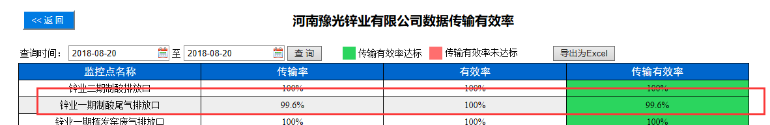
65 AutoMonitorDBV3
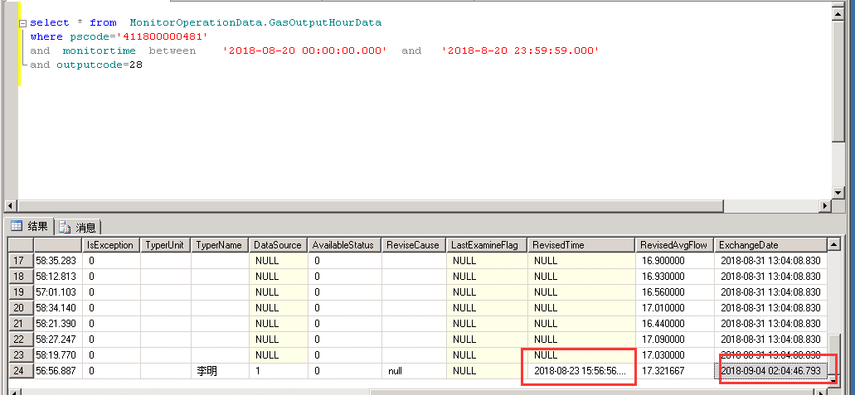

65 AutoMonitorDBV3_Write
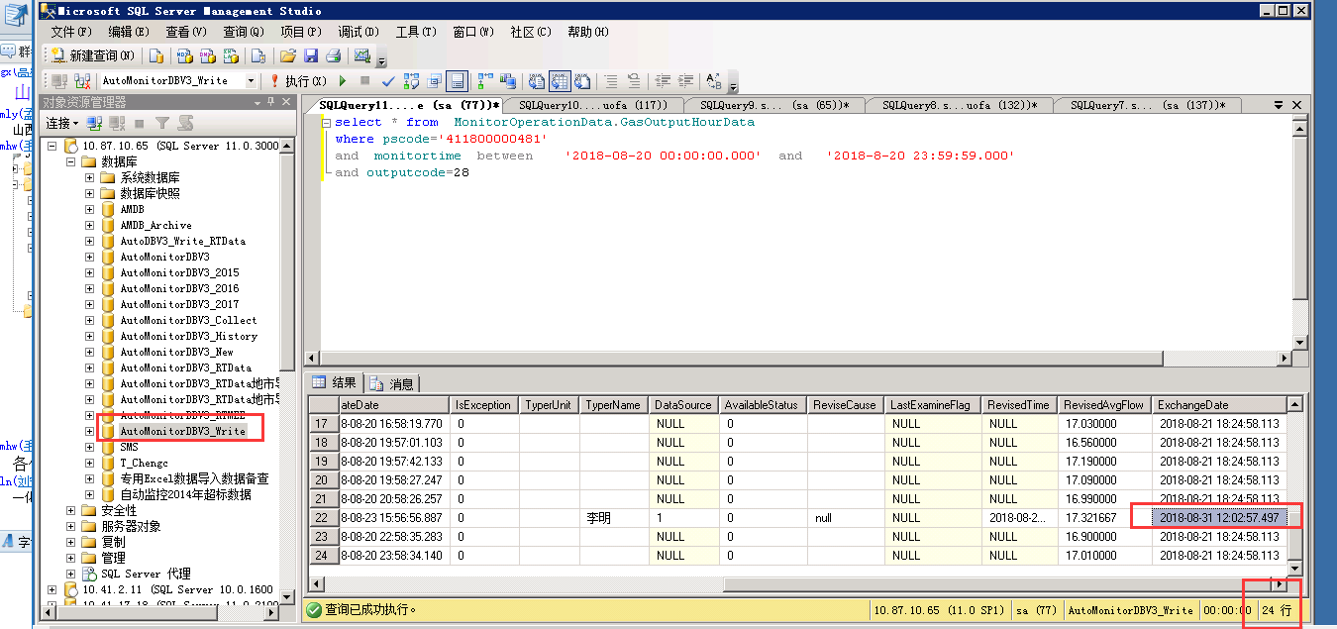

AutoDBV3_Write_RTData库 StatisticsData.DataTransferRate
