山西离柳焦煤集团有限公司汽源厂

25年4月18日标记了工况，但超标督办还是列出来了。



督办按原始值判断超标：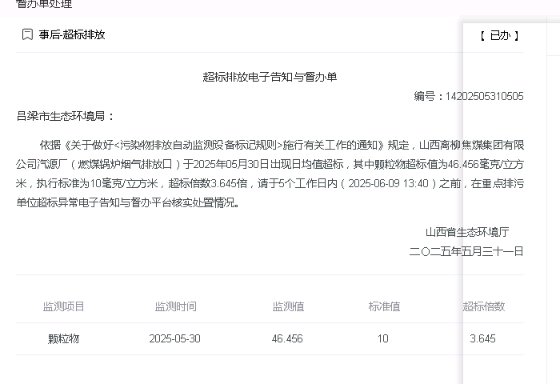

监控数据工况显示停运:

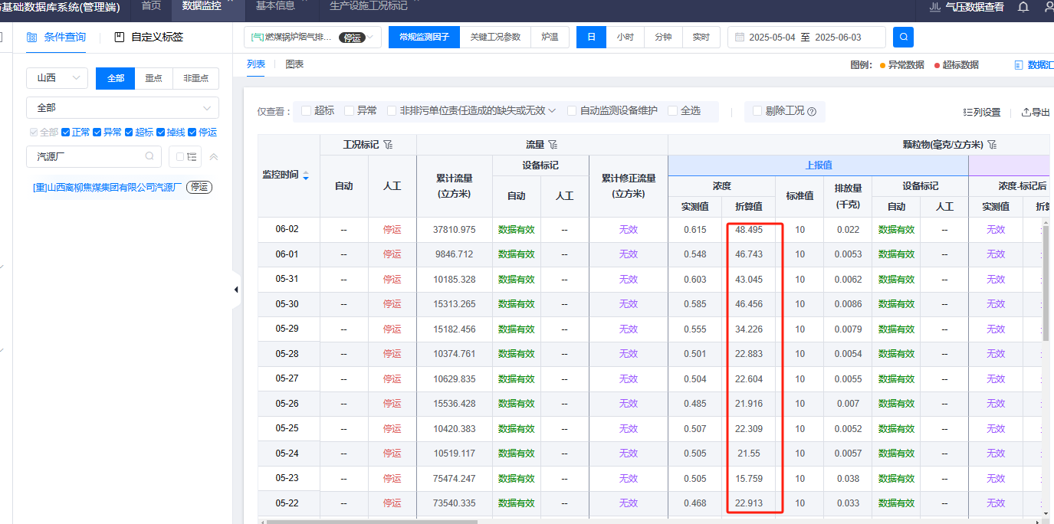

5月30日_日数据json

{

"_id" : "1411810000401520250530000000",

"gd_id" : "0bf27994-3044-4332-83d8-a416dcad0e61",

"mn" : "03581550241850",

"protocol" : "1",

"mp_id" : "14118100004015",

"exchange_type" : "2",

"data_time" : ISODate("2025-05-30T00:00:00.000+08:00"),

"create_time" : ISODate("2025-05-30T23:59:45.302+08:00"),

"update_time" : ISODate("2025-05-31T14:38:29.083+08:00"),

"exchange_time" : ISODate("2025-05-30T23:59:45.302+08:00"),

"_version" : 2,

"values" : [

{

"pollutant_code" : "S01",

"cou_value" : null,

"min_value" : "20.727",

"max_value" : "20.880",

"avg_value" : "20.811",

"min_zs" : null,

"max_zs" : null,

"avg_zs" : null,

"outlet_standard" : null,

"mstatus" : "0",

"sstatus" : "0",

"estatus" : "0",

"astatus" : "0",

"flag" : "N",

"cou_revised" : null,

"avg_revised" : null,

"avg_zs_revised" : null,

"datasource_code" : "1",

"datasource_reason" : "有效数据不足",

"avg_hm_revised" : null,

"datasource_hm_code" : "1",

"datasource_hm_reason" : "有效数据不足"

},

{

"pollutant_code" : "S02",

"cou_value" : null,

"min_value" : "0.030",

"max_value" : "1.765",

"avg_value" : "0.061",

"min_zs" : null,

"max_zs" : null,

"avg_zs" : null,

"outlet_standard" : null,

"mstatus" : "0",

"sstatus" : "0",

"estatus" : "0",

"astatus" : "0",

"flag" : "N",

"cou_revised" : null,

"avg_revised" : null,

"avg_zs_revised" : null,

"datasource_code" : "1",

"datasource_reason" : "有效数据不足"

},

{

"pollutant_code" : "S03",

"cou_value" : null,

"min_value" : "13.632",

"max_value" : "24.576",

"avg_value" : "17.515",

"min_zs" : null,

"max_zs" : null,

"avg_zs" : null,

"outlet_standard" : "",

"mstatus" : "0",

"sstatus" : "0",

"estatus" : "0",

"astatus" : "0",

"flag" : "N",

"cou_revised" : null,

"avg_revised" : null,

"avg_zs_revised" : null,

"datasource_code" : "1",

"datasource_reason" : "有效数据不足"

},

{

"pollutant_code" : "S05",

"cou_value" : null,

"min_value" : "0.934",

"max_value" : "0.978",

"avg_value" : "0.951",

"min_zs" : null,

"max_zs" : null,

"avg_zs" : null,

"outlet_standard" : null,

"mstatus" : "0",

"sstatus" : "0",

"estatus" : "0",

"astatus" : "0",

"flag" : "N",

"cou_revised" : null,

"avg_revised" : null,

"avg_zs_revised" : null,

"datasource_code" : "1",

"datasource_reason" : "有效数据不足"

},

{

"pollutant_code" : "S08",

"cou_value" : null,

"min_value" : "-0.0126",

"max_value" : "0.0522",

"avg_value" : "0.0179",

"min_zs" : null,

"max_zs" : null,

"avg_zs" : null,

"outlet_standard" : "",

"mstatus" : "0",

"sstatus" : "0",

"estatus" : "0",

"astatus" : "0",

"flag" : "N",

"cou_revised" : null,

"avg_revised" : null,

"avg_zs_revised" : null,

"datasource_code" : "1",

"datasource_reason" : "有效数据不足"

},

{

"pollutant_code" : "B02",

"cou_value" : "15313.265",

"min_value" : "0.087",

"max_value" : "5.097",

"avg_value" : "0.177",

"min_zs" : null,

"max_zs" : null,

"avg_zs" : null,

"outlet_standard" : null,

"mstatus" : "0",

"sstatus" : "0",

"estatus" : "0",

"astatus" : "0",

"flag" : "N",

"cou_revised" : null,

"avg_revised" : null,

"avg_zs_revised" : null,

"datasource_code" : "1",

"datasource_reason" : "有效数据不足"

},

{

"pollutant_code" : "001",

"cou_value" : "0.0086",

"min_value" : "0.3892",

"max_value" : "0.7542",

"avg_value" : "0.5853",

"min_zs" : "22.1539",

"max_zs" : "85.6093",

"avg_zs" : "46.4560",

"outlet_standard" : "10",

"mstatus" : "0",

"sstatus" : "0",

"estatus" : "0",

"astatus" : "1",

"flag" : "N",

"cou_revised" : null,

"avg_revised" : null,

"avg_zs_revised" : null,

"datasource_code" : "1",

"datasource_reason" : "有效数据不足",

"rstatus" : "1",

"rstatus_reason" : "有效数据不足",

"datasource_zs_code" : "1",

"datasource_zs_reason" : "涉及因子无效",

"avg_hm_revised" : null,

"datasource_hm_code" : "1",

"datasource_hm_reason" : "有效数据不足",

"avg_zs_hm_revised" : null,

"datasource_zs_hm_code" : "1",

"datasource_zs_hm_reason" : "涉及因子无效"

},

{

"pollutant_code" : "002",

"cou_value" : "0",

"min_value" : "-0.087",

"max_value" : "0.115",

"avg_value" : "0.021",

"min_zs" : "-8.489",

"max_zs" : "11.671",

"avg_zs" : "1.667",

"outlet_standard" : "35",

"mstatus" : "0",

"sstatus" : "0",

"estatus" : "0",

"astatus" : "0",

"flag" : "N",

"cou_revised" : null,

"avg_revised" : null,

"avg_zs_revised" : null,

"datasource_code" : "1",

"datasource_reason" : "有效数据不足",

"rstatus" : "1",

"rstatus_reason" : "有效数据不足",

"datasource_zs_code" : "1",

"datasource_zs_reason" : "涉及因子无效",

"avg_hm_revised" : null,

"datasource_hm_code" : "1",

"datasource_hm_reason" : "有效数据不足",

"avg_zs_hm_revised" : null,

"datasource_zs_hm_code" : "1",

"datasource_zs_hm_reason" : "涉及因子无效"

},

{

"pollutant_code" : "003",

"cou_value" : "-0.001",

"min_value" : "-0.807",

"max_value" : "0.704",

"avg_value" : "-0.127",

"min_zs" : "-73.313",

"max_zs" : "68.343",

"avg_zs" : "-10.099",

"outlet_standard" : "50",

"mstatus" : "0",

"sstatus" : "0",

"estatus" : "0",

"astatus" : "0",

"flag" : "N",

"cou_revised" : null,

"avg_revised" : null,

"avg_zs_revised" : null,

"datasource_code" : "1",

"datasource_reason" : "有效数据不足",

"rstatus" : "1",

"rstatus_reason" : "有效数据不足",

"datasource_zs_code" : "1",

"datasource_zs_reason" : "涉及因子无效",

"avg_hm_revised" : null,

"datasource_hm_code" : "1",

"datasource_hm_reason" : "有效数据不足",

"avg_zs_hm_revised" : null,

"datasource_zs_hm_code" : "1",

"datasource_zs_hm_reason" : "涉及因子无效"

}

],

"refresh_flag" : "0",

"persist_time" : ISODate("2025-05-31T14:36:57.840+08:00")

}