## **陵川鑫源冶炼有限责任公司**

督办按原始值判断超标

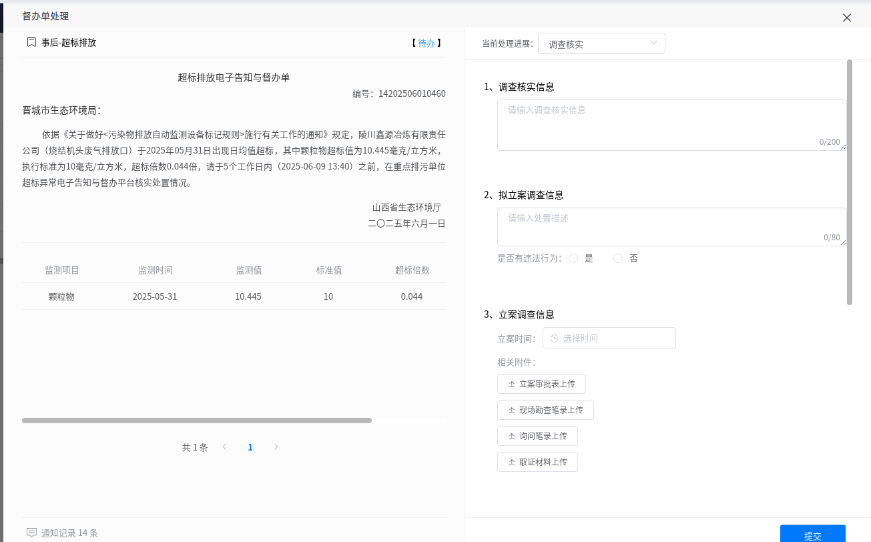

监控数据修正后不超标:

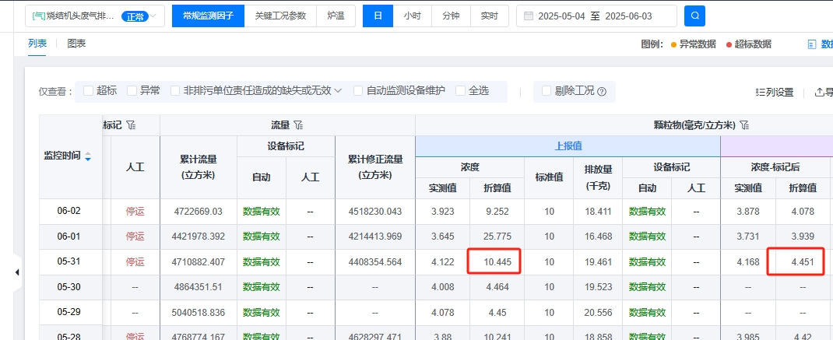

5月31日_日数据json

{

"_id" : "1400000002901520250531000000",

"gd_id" : "5697b415-dc31-4190-93ff-e95075a42023",

"mn" : "03562450101651",

"protocol" : "1",

"mp_id" : "14000000029015",

"exchange_type" : "2",

"data_time" : ISODate("2025-05-31T00:00:00.000+08:00"),

"create_time" : ISODate("2025-06-01T00:03:36.776+08:00"),

"update_time" : ISODate("2025-06-01T12:10:10.633+08:00"),

"exchange_time" : ISODate("2025-06-01T00:03:36.776+08:00"),

"_version" : 2,

"values" : [

{

"pollutant_code" : "002",

"cou_value" : "63.966",

"min_value" : "0",

"max_value" : "31.376",

"avg_value" : "12.983",

"min_zs" : "0",

"max_zs" : "59.810",

"avg_zs" : "14.895",

"outlet_standard" : "35",

"mstatus" : "0",

"sstatus" : "0",

"estatus" : "0",

"astatus" : "0",

"flag" : "N",

"cou_revised" : "61.654",

"avg_revised" : "13.986",

"avg_zs_revised" : "14.935915",

"datasource_code" : "4",

"datasource_reason" : null,

"rstatus" : "2",

"rstatus_reason" : null,

"datasource_zs_code" : "4",

"datasource_zs_reason" : null,

"avg_hm_revised" : "13.986",

"datasource_hm_code" : "4",

"datasource_hm_reason" : null,

"avg_zs_hm_revised" : "14.935915",

"datasource_zs_hm_code" : "4",

"datasource_zs_hm_reason" : null

},

{

"pollutant_code" : "a21003",

"cou_value" : "64.194",

"min_value" : "0",

"max_value" : "26.197",

"avg_value" : "12.873",

"min_zs" : "0",

"max_zs" : "68.430",

"avg_zs" : "14.833",

"outlet_standard" : null,

"mstatus" : "0",

"sstatus" : "0",

"estatus" : "0",

"astatus" : "0",

"flag" : "N",

"cou_revised" : "62.818",

"avg_revised" : "14.24",

"avg_zs_revised" : "15.207166",

"datasource_code" : "4",

"datasource_reason" : null,

"rstatus" : "2",

"rstatus_reason" : null,

"datasource_zs_code" : "4",

"datasource_zs_reason" : null,

"avg_hm_revised" : "14.24",

"datasource_hm_code" : "4",

"datasource_hm_reason" : null,

"avg_zs_hm_revised" : "15.207166",

"datasource_zs_hm_code" : "4",

"datasource_zs_hm_reason" : null

},

{

"pollutant_code" : "S01",

"cou_value" : null,

"min_value" : "12.958",

"max_value" : "20.875",

"avg_value" : "16.644",

"min_zs" : null,

"max_zs" : null,

"avg_zs" : null,

"outlet_standard" : null,

"mstatus" : "0",

"sstatus" : "0",

"estatus" : "0",

"astatus" : "0",

"flag" : "N",

"cou_revised" : null,

"avg_revised" : "16.318",

"avg_zs_revised" : null,

"datasource_code" : "4",

"datasource_reason" : null,

"avg_hm_revised" : "16.318",

"datasource_hm_code" : "4",

"datasource_hm_reason" : null

},

{

"pollutant_code" : "a34013_G",

"cou_value" : "0",

"min_value" : "2.030",

"max_value" : "20",

"avg_value" : "2.931",

"min_zs" : null,

"max_zs" : null,

"avg_zs" : null,

"outlet_standard" : null,

"mstatus" : "0",

"sstatus" : "0",

"estatus" : "0",

"astatus" : "0",

"flag" : "N",

"cou_revised" : "0",

"avg_revised" : "2.941",

"avg_zs_revised" : "3.140749",

"datasource_code" : "4",

"datasource_reason" : null,

"rstatus" : "2",

"rstatus_reason" : null,

"datasource_zs_code" : "4",

"datasource_zs_reason" : null,

"avg_hm_revised" : "2.941",

"datasource_hm_code" : "4",

"datasource_hm_reason" : null,

"avg_zs_hm_revised" : "3.140749",

"datasource_zs_hm_code" : "4",

"datasource_zs_hm_reason" : null

},

{

"pollutant_code" : "S05",

"cou_value" : null,

"min_value" : "2.320",

"max_value" : "8.100",

"avg_value" : "6.250",

"min_zs" : null,

"max_zs" : null,

"avg_zs" : null,

"outlet_standard" : null,

"mstatus" : "0",

"sstatus" : "0",

"estatus" : "0",

"astatus" : "0",

"flag" : "N",

"cou_revised" : null,

"avg_revised" : "6.543",

"avg_zs_revised" : null,

"datasource_code" : "4",

"datasource_reason" : null

},

{

"pollutant_code" : "S03",

"cou_value" : null,

"min_value" : "29.894",

"max_value" : "102.622",

"avg_value" : "95.744",

"min_zs" : null,

"max_zs" : null,

"avg_zs" : null,

"outlet_standard" : "",

"mstatus" : "0",

"sstatus" : "0",

"estatus" : "0",

"astatus" : "0",

"flag" : "N",

"cou_revised" : null,

"avg_revised" : "98.303",

"avg_zs_revised" : null,

"datasource_code" : "4",

"datasource_reason" : null

},

{

"pollutant_code" : "S08",

"cou_value" : null,

"min_value" : "-0.095",

"max_value" : "0",

"avg_value" : "-0.058",

"min_zs" : null,

"max_zs" : null,

"avg_zs" : null,

"outlet_standard" : "",

"mstatus" : "0",

"sstatus" : "0",

"estatus" : "0",

"astatus" : "0",

"flag" : "N",

"cou_revised" : null,

"avg_revised" : "-0.061",

"avg_zs_revised" : null,

"datasource_code" : "4",

"datasource_reason" : null

},

{

"pollutant_code" : "S02",

"cou_value" : null,

"min_value" : "0.020",

"max_value" : "11.234",

"avg_value" : "9.659",

"min_zs" : null,

"max_zs" : null,

"avg_zs" : null,

"outlet_standard" : null,

"mstatus" : "0",

"sstatus" : "0",

"estatus" : "0",

"astatus" : "0",

"flag" : "N",

"cou_revised" : null,

"avg_revised" : "10.341",

"avg_zs_revised" : null,

"datasource_code" : "4",

"datasource_reason" : null

},

{

"pollutant_code" : "001",

"cou_value" : "19.461",

"min_value" : "2.510",

"max_value" : "24.118",

"avg_value" : "4.122",

"min_zs" : "2.803",

"max_zs" : "319.963",

"avg_zs" : "10.445",

"outlet_standard" : "10",

"mstatus" : "0",

"sstatus" : "0",

"estatus" : "0",

"astatus" : "1",

"flag" : "N",

"cou_revised" : "18.351",

"avg_revised" : "4.168",

"avg_zs_revised" : "4.451086",

"datasource_code" : "4",

"datasource_reason" : null,

"rstatus" : "2",

"rstatus_reason" : null,

"datasource_zs_code" : "4",

"datasource_zs_reason" : null,

"avg_hm_revised" : "4.168",

"datasource_hm_code" : "4",

"datasource_hm_reason" : null,

"avg_zs_hm_revised" : "4.451086",

"datasource_zs_hm_code" : "4",

"datasource_zs_hm_reason" : null

},

{

"pollutant_code" : "003",

"cou_value" : "98.405",

"min_value" : "0",

"max_value" : "40.160",

"avg_value" : "19.733",

"min_zs" : "0",

"max_zs" : "104.902",

"avg_zs" : "22.739",

"outlet_standard" : "50",

"mstatus" : "0",

"sstatus" : "0",

"estatus" : "0",

"astatus" : "0",

"flag" : "N",

"cou_revised" : "96.288",

"avg_revised" : "21.827",

"avg_zs_revised" : "23.309468",

"datasource_code" : "4",

"datasource_reason" : null,

"rstatus" : "2",

"rstatus_reason" : null,

"datasource_zs_code" : "4",

"datasource_zs_reason" : null,

"avg_hm_revised" : "21.827",

"datasource_hm_code" : "4",

"datasource_hm_reason" : null,

"avg_zs_hm_revised" : "23.309468",

"datasource_zs_hm_code" : "4",

"datasource_zs_hm_reason" : null

},

{

"pollutant_code" : "B02",

"cou_value" : "4710882.407",

"min_value" : "0.143",

"max_value" : "63.873",

"avg_value" : "54.524",

"min_zs" : null,

"max_zs" : null,

"avg_zs" : null,

"outlet_standard" : null,

"mstatus" : "0",

"sstatus" : "0",

"estatus" : "0",

"astatus" : "0",

"flag" : "N",

"cou_revised" : "4408354.564",

"avg_revised" : null,

"avg_zs_revised" : null,

"datasource_code" : "4",

"datasource_reason" : null

}

],

"refresh_flag" : "0",

"persist_time" : ISODate("2025-06-01T12:00:45.672+08:00")

}