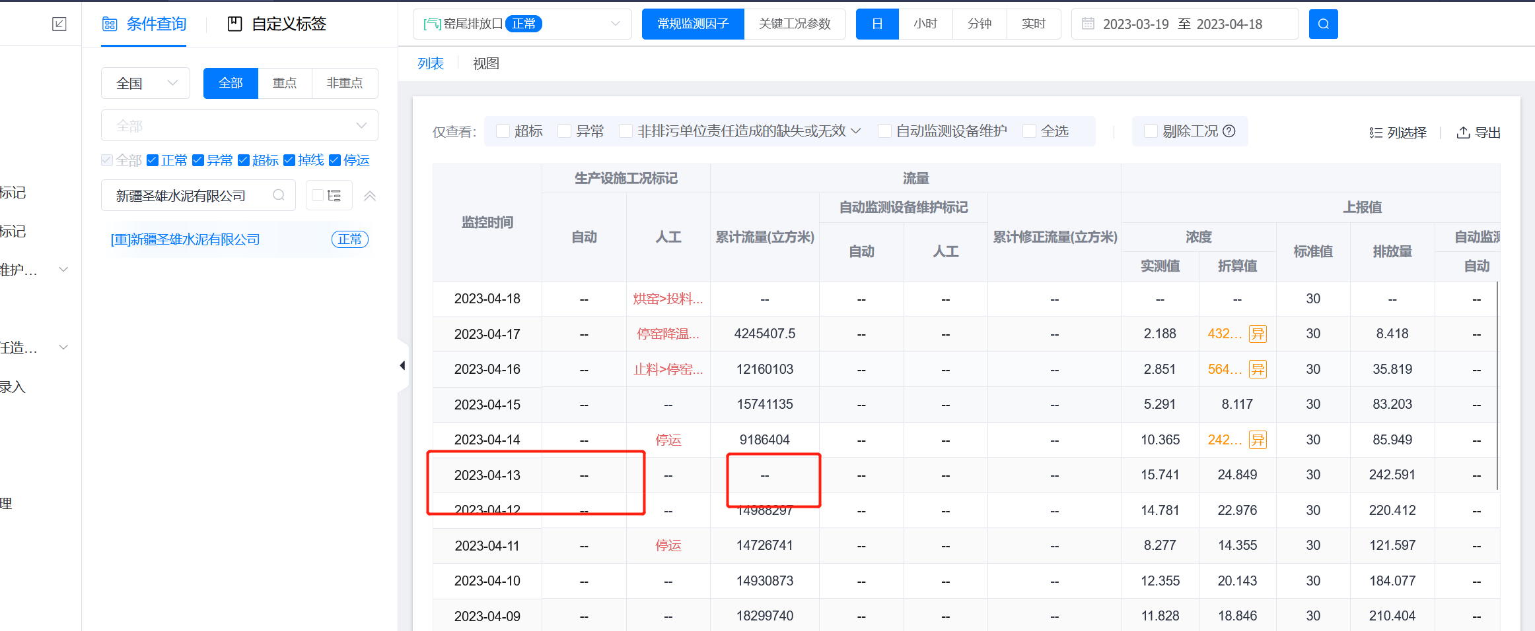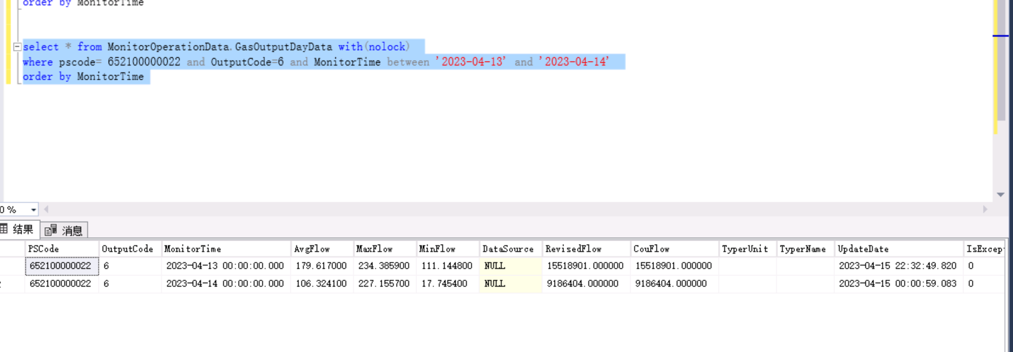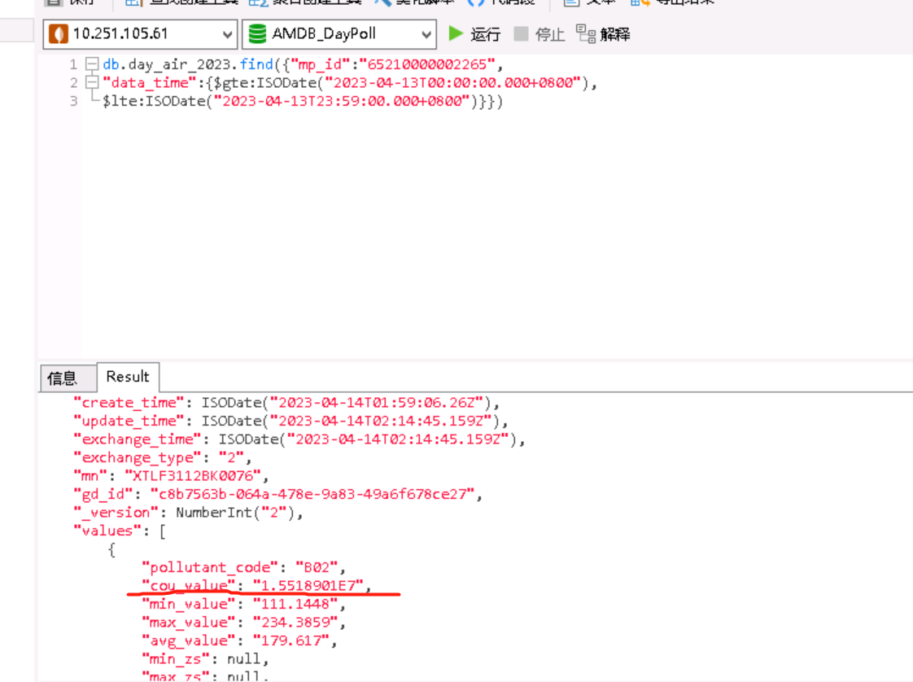            "pollutant_code": "B02",  
            "cou_value": "1.5518901E7",  
            "min_value": "111.1448",  
            "max_value": "234.3859",  
            "avg_value": "179.617",  
  
新疆圣雄水泥有限公司 窑尾排放口 日数据 4月13日 流量平台不显示值，排查发现，SqlServer数据库中是CouFlow  
15518901.000000，到了MongoDB库   "cou_value": "1.5518901E7"

--sqlserver查询

select * from MonitorOperationData.GasOutputDayData with(nolock)

where pscode= 652100000022 and OutputCode=6 and MonitorTime between '2023-04-13' and '2023-04-14'

order by MonitorTime

--MongoDB查询

db.day_air_2023.find({"mp_id":"65210000002265",

"data_time":{$gte:ISODate("2023-04-13T00:00:00.000+0800"),

$lte:ISODate("2023-04-13T23:59:00.000+0800")}})